Structure Design:
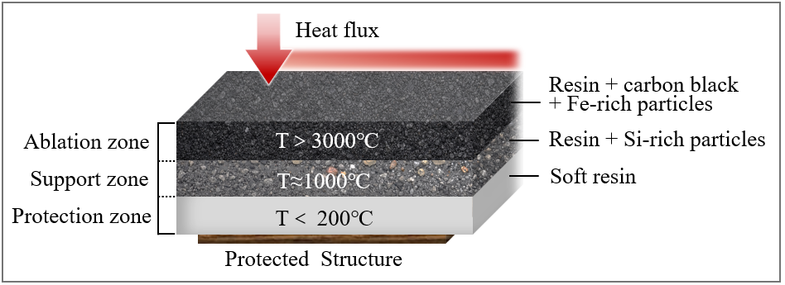

Material:
Ablation zone | Carbon black, Fe-rich particle, photo initiator, resin
Support zone | Si-rich particles, resin
Protection zone | resin

Target: The goal is to find a formulation with low backside temperature, low ablative rate, and low density. Since thermal protection is the main requirement, backside temperature is prioritized first. The final goal is to build a selection map/model that helps choose material variables satisfying low density and low ablative rate under a given temperature requirement.

First zone (13 group x 3 replicates):
Variable | Response
Carbon black concentration | Linear ablative rate
Fe-rich regolith concentration | Backside temperature
 | Density
I-369, the photo initiator weight ratio is fixed as 2wt%. The weight ratio of resin is calculated through: $w(resin)=100\%-w(carbon black)-w(Fe regolith)-w(I369)$
Ablation zone (4 should be 100% in total; 2% is fixed) 2 independent variables; 3 outputs (smaller is better);
(increase the first two Linear ablative rate (µm/s) Backside temp. (°C) up but density down)
Carbon black wt% | Fe-rich regolith wt% | I-369 wt% | Resin wt% | Linear ablative rate (µm/s) | Backside temp. (°C) | Density (g/cm³)
5 | 1 | 2 | 92 | 17.68 | 214 | 1.135
5 | 1 | 2 | 92 | 18.74 | 227 | 1.135
5 | 1 | 2 | 92 | 19.21 | 216 | 1.135
5 | 2 | 2 | 91 | 14.62 | 217 | 1.144
5 | 2 | 2 | 91 | 16.17 | 218 | 1.144
5 | 2 | 2 | 91 | 15.58 | 209 | 1.144
5 | 3 | 2 | 90 | 11.50 | 213 | 1.153
5 | 3 | 2 | 90 | 10.78 | 225 | 1.153
5 | 3 | 2 | 90 | 12.07 | 183 | 1.153
5 | 4 | 2 | 89 | 11.68 | 202 | 1.163
5 | 4 | 2 | 89 | 10.24 | 214 | 1.163
5 | 4 | 2 | 89 | 11.21 | 206 | 1.163
5 | 5 | 2 | 88 | 11.65 | 198 | 1.173
5 | 5 | 2 | 88 | 10.54 | 206 | 1.173
5 | 5 | 2 | 88 | 9.97 | 208 | 1.173
10 | 3 | 2 | 85 | 6.80 | 219 | 1.177
10 | 3 | 2 | 85 | 7.85 | 202 | 1.177
10 | 3 | 2 | 85 | 6.43 | 201 | 1.177
12.5 | 1 | 2 | 84.5 | 6.30 | 209 | 1.170
12.5 | 1 | 2 | 84.5 | 7.38 | 215 | 1.170
12.5 | 1 | 2 | 84.5 | 7.57 | 219 | 1.170
12.5 | 3 | 2 | 82.5 | 6.53 | 209 | 1.190
12.5 | 3 | 2 | 82.5 | 7.08 | 189 | 1.190
12.5 | 3 | 2 | 82.5 | 6.82 | 192 | 1.190
12.5 | 5 | 2 | 80.5 | 6.10 | 198 | 1.211
12.5 | 5 | 2 | 80.5 | 7.48 | 204 | 1.211
12.5 | 5 | 2 | 80.5 | 6.78 | 186 | 1.211
15 | 3 | 2 | 80 | 6.97 | 213 | 1.202
15 | 3 | 2 | 80 | 7.03 | 198 | 1.202
15 | 3 | 2 | 80 | 5.92 | 165 | 1.202
20 | 1 | 2 | 77 | 5.76 | 186 | 1.207
20 | 1 | 2 | 77 | 6.68 | 183 | 1.207
20 | 1 | 2 | 77 | 6.08 | 184 | 1.207
20 | 3 | 2 | 75 | 6.72 | 161 | 1.229
20 | 3 | 2 | 75 | 5.58 | 175 | 1.229
20 | 3 | 2 | 75 | 5.92 | 172 | 1.229
20 | 5 | 2 | 73 | 6.28 | 174 | 1.251
20 | 5 | 2 | 73 | 6.38 | 168 | 1.251
20 | 5 | 2 | 73 | 5.53 | 163 | 1.251
13 conditions
Already have a physical theoretical model (output is not the same)
1-2 weeks

Total structure (3 group x 3 replicates)
Variable | Response
Carbon black concentration | Linear ablative rate
Fe-rich particle concentration | Backside temperature
Si-rich particle concentration | Total density
I-369, the photo initiator weight ratio of first zone is fixed as 2wt%. The weight ratio of first zone resin is calculated through:
$$w(resin1)=100\%-w(carbon black)-w(Fe regolith)-w(I369)$$
The weight ratio of second zone resin is calculated through:
$$w(resin2)=100\%-w(Si regolith)$$
First-zone carbon black wt% | First-zone Fe-rich wt% | First-zone I-369 wt% | First-zone resin wt% | Second-zone Si-rich wt% | Second-zone resin wt% | Linear ablative rate (µm/s) | Backside temp. (°C) | Total density (g/cm³)
20 | 3 | 2 | 75 | 50 | 50 | 6.17 | 165 | 1.297
20 | 3 | 2 | 75 | 50 | 50 | 5.77 | 150 | 1.297
20 | 3 | 2 | 75 | 50 | 50 | 5.68 | 153 | 1.297
20 | 3 | 2 | 75 | 60 | 40 | 5.42 | 138 | 1.345
20 | 3 | 2 | 75 | 60 | 40 | 4.73 | 127 | 1.345
20 | 3 | 2 | 75 | 60 | 40 | 4.97 | 145 | 1.345
20 | 3 | 2 | 75 | 70 | 30 | 4.28 | 122 | 1.403
20 | 3 | 2 | 75 | 70 | 30 | 4.33 | 116 | 1.403
20 | 3 | 2 | 75 | 70 | 30 | 4.75 | 118 | 1.403
3 conditions (first zone is fixed)

Last zone does not need to be changed

